# WELCOME

Ms.

Anh Thy

PHAM(U18)

Flight Arrival Date: 28 Sep 2019 Flight Arrival Time: 01:05 Flight Number: 1425

Homestay Address: Mark STACK, 65 Oxford Road, Strathfield, NSW, 2135

Mobile: 0430 021 419

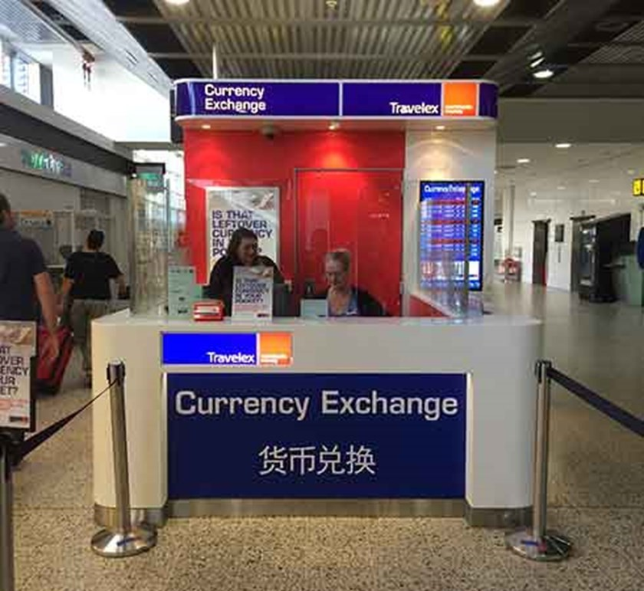

If you arrive at the International Airport:

Once you come out of Customs, your driver

will wait for you in front of ‘Travelex Currency Exchange'

If you arrive at the Domestic Airport:

Please wait for your driver at the 'luggage area' as your driver will meet you there

In case of Emergency please contact:

Your Driver Coordinator (Lynton): (+61) 407 697 941

Global experience emergency number: (+61) 430 008 448

Email: [change@globalexperience.com.au](mailto:change@globalexperience.com.au)

PLEASE DO NOT LEAVE THE AIRPORT, WAIT FOR YOUR DRIVER